Unnormalized Form (UNF)
In an unnormalized table, a single cell might contain multiple values (like a list of phone numbers) or repeating groups.
StudentID | Name | Courses
1 | Alice | Math, Physics
2 | Bob | Biology

First Normal Form (1NF)
Rule: Data must be atomic. This means each cell must contain only one value, and there should be no repeating groups.
1NF Table
StudentID | Name | Course
1 | Alice | Math
1 | Alice | Physics
2 | Bob | Biology

Second Normal Form (2NF)
Rule: Must be in 1NF AND all non-key attributes must be fully dependent on the entire primary key. This eliminates "partial dependencies" (where a column depends on only part of a composite primary key).
To fix this, we split the table. If our primary key was (StudentID, Course), the "Name" only depends on StudentID, not the Course.
Table A: Students  StudentID Name  1 Alice  2 Bob | Table B: Registrations  StudentID Course  1 Math  1 Physics  2 Biology

Third Normal Form (3NF)
Rule: Must be in 2NF AND there must be no transitive dependencies. This means a non-key column shouldn't depend on another non-key column.
Imagine we added "Department Head" to our table. The Head depends on the Department, and the Department depends on the Student. That's a "transitive" chain.
Before 3NF (Violation)
StudentID | Dept | Dept_Head
1 | CS | Dr. Smith

After 3NF (Decomposed)
Table: Students  | StudentID | Dept  | 1 | CS | | Table: Departments |  Dept | Dept_Head |  | CS | Dr. Smith |

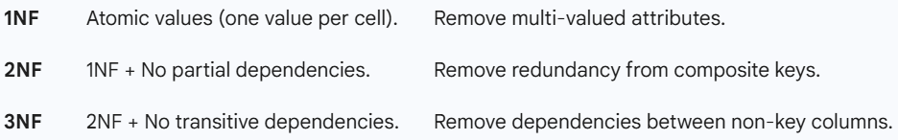

Another example –
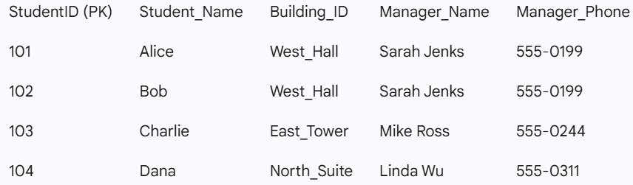

Why this violates 3NF:
- The Dependency: StudentID -> Building_ID -> Manager_Name.
- The Problem: Manager_Name and Manager_Phone are non-key attributes. They don't actually describe the Student; they describe the Building.
- The Violation: The manager’s info is "transitively" dependent on the StudentID via the Building_ID.

Problems Caused by this Violation
If we leave the data like this, we run into three major "Anomalies":
- Update Anomaly: If Sarah Jenks changes her phone number, we have to find every single student living in "West_Hall" and update it multiple times. If we miss one, the data is inconsistent.
- Insertion Anomaly: If the university hires a new manager for a new building but hasn't assigned any students to it yet, we can't record the manager's info because we don't have a StudentID (the Primary Key) to attach them to.
- Deletion Anomaly: If "Dana" (the only student in North_Suite) graduates and we delete her row, we lose all record of who manages North_Suite and what their phone number is.

The Rule of BCNF
"For every non-trivial functional dependency X -> Y, X must be a Super Key."

BCNF Violation: The "Consultant" Example
Imagine a table tracking university Students, the Subjects they study, and the Professors teaching them.
Constraints:
- A Professor teaches only one Subject.
- A Student can study multiple Subjects.
- For a specific Subject, a Student is assigned to only one Professor.

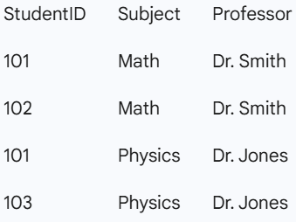

Why this is 3NF but NOT BCNF:
- Candidate Keys: The unique combinations are (StudentID, Subject) or (StudentID, Professor).
- The Dependency: Professor -> Subject (Because Dr. Smith only teaches Math).
- The Problem: Professor is NOT a Super Key

The Solution: Decompose to BCNF
We split the table to ensure that the dependency Professor -> Subject is handled in a place where Professor is the unique ID.

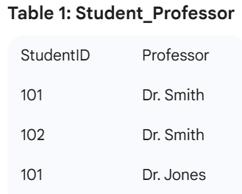 | 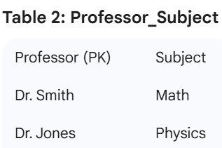

Think yourself


